Performance Assessment | Task 1
Kiara A. Ganger | 007775841
Western Governors University
D205 | DATA ACQUISITION

Question: Are customers with children more prone to have having online security than customers without?
- My question will be answered by counting the ‘Yes’ and ‘No’ in the online_security column in services. Then I will be joining the customer table to the services table using customer_id.
- In order to answer this question, I will be using the “online_security” and the “customer_id” column from the services table and the “customer_id” and the “children” column from the customer table by joining them on “customer_id”.

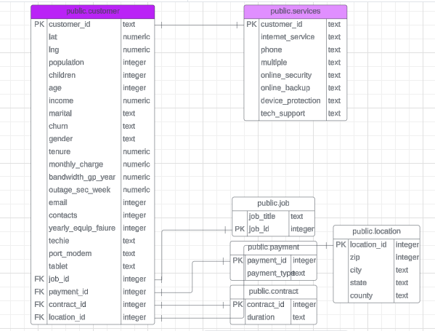
- The relationship between the existing table customer and the created child table services is the customer_id column. Making this a 1:1 relationship.
- To create the services table, I typed in the following query using the query tool in pgAdmin4:
CREATE TABLE services
(customer_id text NOT NULL,
internet_serves text NOT NULL,
phone text NOT NULL,
multiple text NOT NULL,
online_security text NOT NULL,
online_backup text NOT NULL,
device_protection text NOT NULL,
tech_support text NOT NUL,
PRIMARY KEY (customer_id),
CONSTRAINT customer_id_fkey FOREIGN KEY (customer_id)
REFERENCES public.customer (customer_id));
- After creating the table I imported the services files from the c drive successfully and this command was executed by pgAdmin 4 to load the services table:
"\\copy public.services (customer_id, internet_service, phone, multiple, online_security, online_backup, device_protection, tech_support) FROM 'C:/LabFiles/Services.csv' DELIMITER ',' CSV HEADER QUOTE '\"' ESCAPE '''';""

I answered my research question by running the following query:

SELECT

COUNT(CASE WHEN customer.children = 0 THEN 1 ELSE NULL END) AS nk,

COUNT(CASE WHEN customer.children > 0 THEN 1 ELSE NULL END) AS yk,

services.online_security

FROM customer

JOIN services

USING (customer_id)

GROUP BY service.online_security;
(SQL CASE | Intermediate SQL - Mode, 2016)

- This is the outcome of the query ran:
I have also attached the csv file with my submission.

I think the company should have this information updated every two months.
- The time period chosen is relevant because it gives the company insight into how to market their products. If families with children are more likely to use online security, they can adjust their ads to be more family friendly and to pick the best places to run their ads. “Most businesses conduct multiple market research projects a year depending on their needs and resources. Over 80% of companies conduct market research frequently, and 79% conduct at least five market research projects a year” (Haskin, 2023).

Panopto video: https://wgu.hosted.panopto.com/Panopto/Pages/Viewer.aspx?id=6081cadc-cf8d-40ca-ac25-b12e012f4b6e
- I did not use any outside code. These are the sources I used to help justify my research question and the query process.

Sources
Haskin, R. (2023, November 10). Everything You Want to Know About Market Research. Retrieved from Hanover Research: https://www.hanoverresearch.com/insights-blog/what-is-market-research/?org=corporate#:~:text=Most%20businesses%20conduct%20multiple%20market
pgAdmin 4 (2024)
SQL CASE | Intermediate SQL - Mode. (2016, May 23). Mode Resources. https://mode.com/sql-tutorial/sql-case

